Department of Management Information System,

National Chengchi University

2021 Presentation

Group 4A Thematic Reports

Topic Title :

Eat Food Bar

Panelists:

107306067 Ye Mingrong

107306066 Lai Kaiwen

107306021 Li Yujin

107306027 Huang Jiajin,

Date: December 2021

directory

1. Topic summary......................................................... 2
2. Topic Introduction......................................................... 2
3. Requirements Analysis......................................................... 6
4. System Architecture & Description............................................ 8
5. Conclusions and future directions.......................................... 17
6. Reference Data ......................................................... 18
7. **Topic summary**

This project mainly starts from the dietary aspect to solve the most anxious dietary problems in modern people's daily life. Our app system uses the characteristics of users to develop a set of food recommendation software suitable for food lovers who have difficulty making dietary choices, and even suitable for everyone. After solving the basic dining problems, it can be extended from the restaurant recommendation system to the concept of dating.

1. **Topic Introduction**

Today's society gives modern people a wealth of choices in all aspects, resulting in some people often hesitating when faced with choices, from food, clothing, housing and transportation, to the direction of work, their lives seem to be full of choices that stump them.

This kind of problem is called "choice phobia" in medicine, although it is named after the word "fear", but it is not much frightening, but such people will often face difficult choices, easy to be anxious, and it is difficult to make a decision happily, and there are not a few such people in life, every day it seems that there are creditors chasing behind them, and every day I get up to face the problem of what I should choose.

Under such circumstances, we would like to create a user-friendly recommendation system to improve the current social situation from the most basic human requirement - food noodles, which we believe will contribute to the overall social environment and the healthy development of modern people's psychology.

From the user's most extensive dietary preferences as the pre-preparation of the system, through the process of the restaurant recommendation system, the user can find the most suitable restaurant, and finally give feedback scores, and after the user has experienced the choice again and again, let the system modify the recommendation order, so that modern people can make full use of the restaurant recommendation function, and then smoothly improve and optimize the user's quality of life.

Our app system allows users to choose the group, amount, time and location of their dietary preferences in advance, and has developed a set of food recommendation software suitable for food lovers who have difficulty in choosing a meal, and can even be suitable for everyone.

In addition, sometimes the meal is not alone, and it is inevitable that there will be a gathering with relatives, friends or colleagues. Therefore, in order to cope with the so-called "group dining" situation, our system also provides a function for multiple people to recommend restaurants - tables. This function can integrate the dietary preferences and habits of multiple users to allow the system to process recommendations together, so that multiple users who use the dining table function can not only get emotional increases in friendship, but also get extra points in food choices.

The idea of the "making friends" function is that we find that our friends and relatives around us are afraid to eat alone, or we are used to having someone to share our thoughts. Users can find nearby users through their location, and initiate chats and invitations to dinner, so that users can experience that eating is not just a simple thing to eat, but also to meet friends and enjoy the fun of eating with multiple people.

I have browsed major food recommendation websites at home and abroad, and the function is nothing more than providing the function of nearby restaurants and restaurant browsing, etc., lacking the recommendation of multiple users and the connection between users. This special publication is committed to improving the shortcomings of the current situation, and combines a number of technologies to collect user data through recommendation system calculation, user location and system logic analysis, and incorporate appropriate data to improve the restaurant selection problem and give the most appropriate response, so as to improve the accuracy and evaluation results of the entire restaurant recommendation system, and objectively provide the majority of users with the method of dietary choice, so that daily choices are no longer the biggest nightmare for the public.

1. Research motivation and purpose

When faced with many choices, people often do not know how to make a decision because they do not have too many ideas and opinions. Take the theme of our project as an example, for example, there are a variety of restaurants on the Internet, users cannot accurately choose the selected restaurants on the Internet, and if they can make a choice, they must go through many comparisons and sorting, which is a waste of time and energy, and even under the excessive manpower consumption, they still choose a poor result, that is, a poor restaurant.

Therefore, we will collect various restaurant categories, reviews and all kinds of information, so that users can easily and calmly choose the restaurant they want, and let the system propose corresponding restaurant results to users based on the data provided by users. In addition to making it easy for users to get started with the process of recommendation, the use of restaurant recommendations can also more quickly eliminate the small difficulties of life and meet the needs of life and food, so as to improve the quality of life of users.

1. Recommend system results and analysis, and provide feedback

The recommendation method is the most core and critical part of the entire recommendation system, which largely determines the performance of the recommendation system. At present, the main recommendation methods in the market include content-based recommendation, collaborative filtering recommendation, association rule-based recommendation, utility-based recommendation, knowledge-based recommendation, and combination recommendation. Since there are advantages and disadvantages of various recommendation methods, we choose to use "logistic regression" considering the actual applicationto implement our recommendation system. Logistic regression is a recommendation method based on "features", which finds the option with the highest probability of being clicked by users by numerizing the characteristics of the item. There are three main advantages of logistic regression recommendation method, which are the support of its mathematical meaning, high interpretability, and the relative simplicity of the model, which does not have much burden on the performance.

The results of the recommendation will be further modified according to the user's choice or change of habits each time, so as to provide more convenient use and obtain more optimized results next time.

1. **Requirements analysis**
2. The object used by the system

According to the 2020 Industrial Economic Statistics Bulletin of the Statistics Department of the Ministry of Economic Affairs, the total turnover of Taiwan's catering industry in 2019 reached NT$811.6 billion (of which restaurants accounted for 82.5%, beverage shops accounted for 12.2%, and foreign restaurants and group catering contractors accounted for 5.3%), with an annual increase of 4.4%. In addition, according to the Taiwan Trend Research report, the number of profitable entrepreneurs in Taiwan's catering industry reached 153,689 in 2020 and is growing at an average annual growth rate of 4.15%. Based on the above two points, we can find that the demand for outside food is gradually increasing.

The program works according to users' dining preferences and habits through a recommendation system designed by us, so that we can find the most suitable option among tens of thousands of restaurants. At the same time, in addition to recommending personal preferences, the project can also provide restaurant recommendations for more than one person, ensuring that users can also find a restaurant suitable for everyone in an environment where many people can dine. The services provided by this program are suitable for customers of all ages, from students and office workers to the elderly after retirement.

In addition to general users, this project also provides services for the needs of restaurants. The most direct benefit for restaurants is that we can ensure that past customers who refer them through our platform have a high level of interest in the restaurant, in other words, we help restaurants find "first-time" consumers with a high chance of becoming repeat customers, which can have a significant positive impact on the restaurant's revenue in the long run. This project is suitable for small restaurants that have just opened a store, which can attract consumers who like the restaurant category in the early stage of business, and is also suitable for restaurants with a stable customer source to expand their consumer range.

1. The environment in which the system is used

This system currently supports mobile devices in the Android environment, and the positioning function will need to be turned on when using certain functions. In addition, the user's dining habits and consumption at different times will also be recorded at the time of registration, and different recommendations will be made according to the time when the user uses the recommendation function.

1. **System architecture and features**
2. System features:
3. Personal recommendation

Among the tens of thousands of restaurants in Taiwan, this system is committed to helping users quickly filter out the most suitable restaurants for themselves at the moment. At the beginning of the system, we mainly focused on the personal preference data entered by users when registering an account in this system, including the type of restaurant they like (Korean, Chinese, barbecue, hot pot...... etc.), the average consumption and location information in different meal periods, combined with the restaurant data and scores of the system to make the model of the recommendation system, after model comparison, according to the degree of suitability for the user, the preliminary personalized order of recommended restaurants is sorted out to solve the problem of cold start of the recommendation system. After the user uses our system for a period of time, we will record the browsing records of the restaurants that the user browses in the system every time, collect these information and send it back to the background system to update the calculation model, so that the recommendation can be closer and closer to meet the personalized needs.

1. Recommended by multiple people

Whether it's a class reunion, a company dinner, or a family dinner, there is always a common problem when deciding on a restaurant - how to find a restaurant that everyone likes so that everyone can eat to their heart's content during the party without being wronged. In order to be closer to the needs of users in daily use, we also provide a multi-person recommendation function. The principle is similar to the aforementioned personal recommendation function, users must first create an account in the system, fill in the basic dining preferences, and then register to use. Users who participate in the party can first enter each other's accounts on the platform and become friends, select the friends who participate in the party by checking the box, and then they will make recommendations based on the restaurant information and ratings of the system.

1. Making Friends (Eating Together)

Dating software in the market is often based on the user's simple personality preferences, initiating activities, or voice chat to do online dating. The special feature of our system is that we use "food" as a medium for making friends, through the preferences of one user (assuming he likes pot, Thai and stir-fried), and our system will send the information of the user with the same preference to him, so that the user can no longer need to eat alone. In addition, our users can also initiate a meal invitation activity, so that many users can see each other's information and make friends through eating.

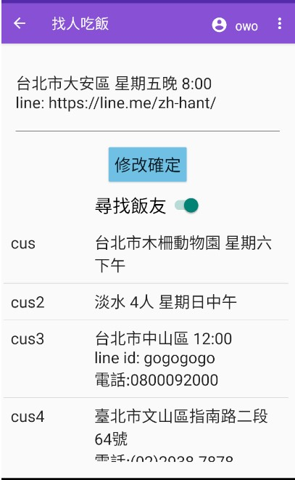

(Figure 1) Dating page

1. The main use process
2. consumer
3. Register and enter personal information

Before the general consumer uses the main function of the system, if he has not become a member of the system, he needs to register an account in the system first, and the personal preference information to be entered when registering the account, including the type of restaurant he likes (Korean, Chinese, barbecue, hot pot...... If you are already a member, you can directly enter your account password and choose to log in as a user.

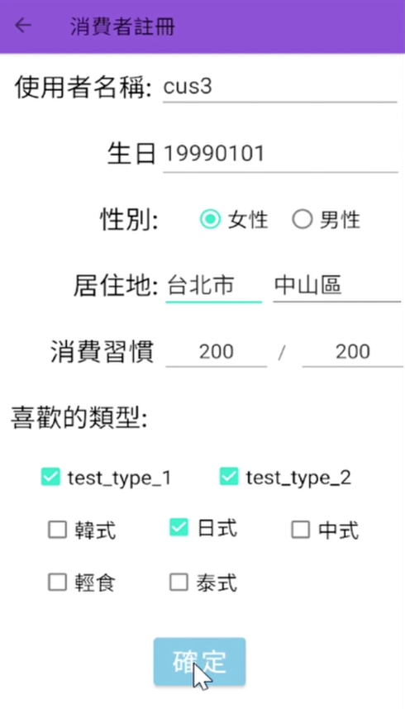

(Figure 2) Consumer registration page

1. Go to the main page and select a service

When you log in as a consumer, you will be taken to the main function page of the consumer, where we will present all the functions provided by the system to the user (Figure 3).), which are personal recommendations, table functions (multiple recommendations), all restaurant lists, dinner parties (dating), and modifying personal basic information.

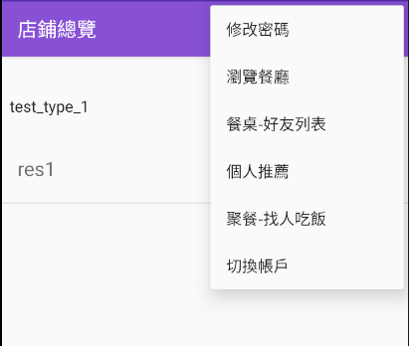

(Fig. 3) The screen where the consumer selects a function

1. After selecting the function, the system starts to provide services

When the user selects the table function, the system will first display a friend list for the user to select the person who is having the dinner together, and at the same time, you can also add new friends here (Figure 4). After selecting the recommendation function, the system will display the recommendation results sorted by our recommendation system (Figure 5). As can be seen from Figure 5, users can click on each restaurant to view the basic information, and if there is a restaurant registered on our platform, the menu will be displayed. The system will record the number of clicks on the restaurant on the platform to optimize future recommendations.

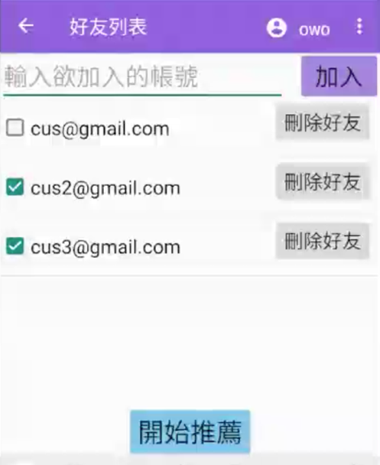

(Figure 4) Multi-person recommended friend list

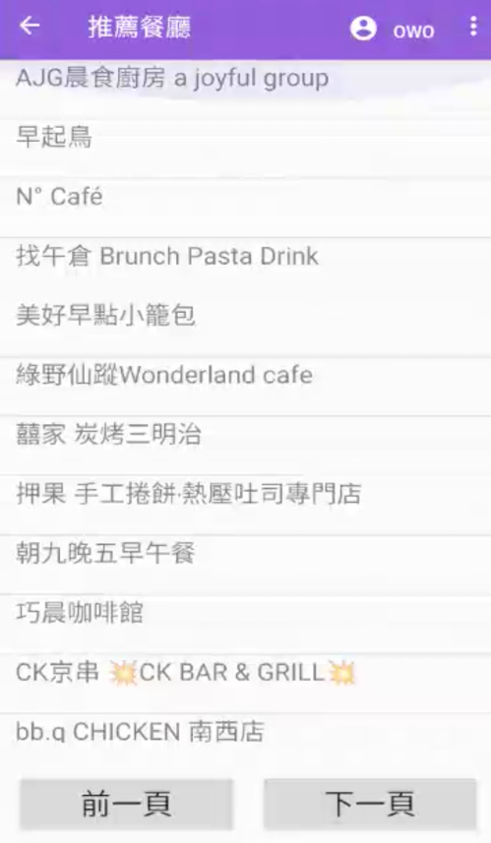

(Figure 5) Recommended list

1. restaurant
2. Register and enter restaurant information

After the restaurant becomes a member of the system, the restaurant will be asked to enter its basic information, including the name of the restaurant, the address of the restaurant, the type of restaurant, the average consumption and the menu. Once registered, it will be displayed on the user's restaurant list.

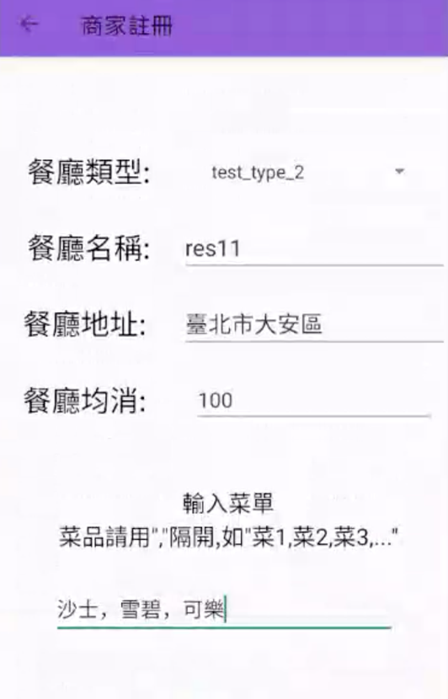

(Figure 6) Restaurant registration screen

1. Once you are logged in, you will be able to view the restaurant backstage

At this stage, the system provides the backend function of the restaurant side, in addition to modifying the basic information and menu of the restaurant, it also provides the restaurant to understand the number of clicks by users on the App, as well as the main competitors with the highest popularity of restaurants of the same type in the system, so that the restaurant can understand the trend and adjust its strategy.

1. System development tools and techniques
2. System framework

The system is mainly developed as an Android App, the front-end is developed using Android Studio, and the main back-end functions are developed in Java language. The database part uses MySQL to store data.

1. Recommender system

The recommendation function of this system uses the "logistic regression" method in the field of recommender system. Logistic regression is a kind of generalized linear model, and his assumption is that the dependent variable y obeys the statistical distribution of white effort, and in the CTR (click probability) prediction problem, whether the "click" event occurs or not is the dependent variable of the model, so "logistic regression" as a CTR prediction model is in line with the physical meaning of the "click" event. Logistic regression is applied in recommender systems, that is, the weighted sum of the features is applied to the sigmoid function. Through the sigmoid function, its value can correspond to 0~1, which is exactly in line with our concept of click probability. In practice, we convert the user's characteristics, item attributes, time, and location into numerical feature vectors. The optimization goal of the logistic regression model is to obtain the probability of the user "clicking" the item by inferring all the feature vectors into the logistic regression model. Finally, use the click probability to sort the items to get the final list of recommendations.

1. Restaurant information

The Python Selenium and BeautifulSoup crawlers crawl the online restaurant information as the preliminary basic information of the restaurant recommendation on the system, and the subsequent restaurant information is expected to be modified and provided by the restaurant after registering in the system.

1. Dating

Connect to the database with Android Studio and use the original user information to connect with Android The information of the location of the app is comprehensively processed to transmit the information of one user to the other party, and enable the two parties to interact.

1. Description of the division of labor

|  |  |
| --- | --- |
| Team member's name | Division of labor content |
| Ye Mingrong | Recommendation system, restaurant listing, presentation and reporting |
| Lai Kaiwen | Recommendation system, restaurant backstage, click-through rate, presentation production and reporting |
| Li Yujin | Login registration, friend list, make friends, backend composing |
| Huang Jiajin | Front-end Android Studio, interface design, video |

1. **Conclusions and future directions**

Coupled with the global impact of the pandemic this year, the demand for ordering food at home is growing, and it is believed that even after the epidemic, the demand for food will increase significantly in the future, so our app will not only make it easier for users to solve their dietary needs, but also improve the quality of life in the future. In the future, we plan to bring the project to market from two business models:

1. Partnering with the restaurant side

By introducing users to restaurants through our app, restaurants can cooperate with us by placing advertisements or giving exclusive discount codes to the platform, so that users through our app can be identified by the restaurant, which may reduce the loss of restaurant marketing and publicity.

1. Upgrade to Gold Membership

Let Gold members get exclusive discount codes for restaurants, rather than just food and beverage recommendations. And send the latest restaurant information by email so that users have more opportunities to choose better restaurants.

In addition, gold members can get more dating information, can obtain a wider range of user information and user profiles, and launch members-exclusive activities.

1. **Resources**

[1] Taiwan Trend Study

<https://www.twtrend.com/trend-detail/food-and-beverage-service-activities-2021/>

[2] Statistics from the Ministry of Economic Affairs

<https://www.moea.gov.tw/Mns/dos/bulletin/Bulletin.aspx?kind=9&html=1&menu_id=18808&bull_id=6878>

[3] Silicon Valley veteran master takes you to learn deep learning recommender system – Wang Zhe

[4] Understanding the Recommendation System Algorithm from Practice – Wang Meiling

[5] Always hesitating, do you have a "phobia of choice"?

<https://www.top1health.com/Article/82561>

[6] Are you hungry? Don't know what to eat?

<https://beauty-upgrade.tw/15661/>

[7] Commonly used algorithms in recommender systems and comparison of advantages and disadvantages

<https://kknews.cc/zh-tw/tech/l6egrme.html>

[8] Use VS code to create an exclusive dating app for programmers

<https://www.kocpc.com.tw/archives/361071>

[9] Hahow Recommendation System Teaching

<https://hahow.in/courses/5c8b58b5669d56001f348f69/main?device=c&tracking=google-ads-DSA&gclid=EAIaIQobChMI7Nboi7_U8wIVTB0rCh3ZNALAEAAYASAAEgKeNvD_BwE>

[10] Best Practices on Recommendation Systems - GitHub

<https://github.com/microsoft/recommenders>

[11] Best Practices on Recommendation Systems – GitHub

<https://github.com/TryCatchLearn/DatingApp>